ZSight – missed pickup logic workflow



Document ID | DigDev_ZSight_Missed_Pickup_Logic_v1.0
Product | ZSight
Environment | All
Confidentiality Level | Internal / Restricted

Contents
1 DOCUMENT INFORMATION 3
1.1 Validation 3
1.2 Document Distribution 3
1.3 Version Control 3
2 PREFACE 4
2.1 About this document 4
2.2 Related documents 4
2.3 Who should read this document 4
2.4 Terminology 4
2.5 Conventions Used 5
3 MISSED PICKUP MODEL 6
3.1 Overview 6
3.2 Inputs 7
3.3 User Roles 7
4 missed pickup SYSTEM LOGIC 8
4.1 Rule Set 8
4.2 Feed Evaluation 9
4.3 Notification Lifecycle 10
4.4 Known Limits 10
5 missed pickup WORKING PROCEDURES 11
5.1 Configure Container Service Days 11
5.1.1 Procedure 11
6 APPROVAL SIGNATURES 12

DOCUMENT INFORMATION

Validation
Name |  | Role | Date (dd/mm/aa)
Issued by | Oscar Rondon | Technical Writer | 18/08/2026
Verified by | Ezequiel Garcia | Developer | 18/08/2026
Approved by | Anthony Bures | Digital Development Manager | 18/08/2026

Document Distribution
Name | Role
Oscar Rondon | Technical Writer
Anthony Bures | Digital Development Manager
Ezequiel Garcia | Developer

Version Control
Version | Date | Author | Description of changes
1.0 | 18/08/2026 | Oscar Rondon | 1st version of the functional design document for the missed pickup logic workflow in ZSight.

PREFACE

About this document
This document defines the logic ZSight uses to determine that a scheduled pickup did not happen, and to raise a missed pickup notification when it detects one. It exists to give development, QA, support and business stakeholders a single agreed description of that logic.
The rule set that determines a missed pickup, the evaluation performed on each device report, the notification lifecycle, and the conditions under which a missed pickup cannot be determined.

Related documents
All documents or elements used for reference are presented in the following table:
Title | Reference | Author | Version
ZSight User Guide | ZSight User Guide | Oscar Rondon | 1.0
Tago Asset Feed API | Event definitions received from the device provider |  | N/A

Who should read this document
This document is written for readers who need to understand why ZSight reports a container pickup as missed in the system.
- Developers and QA engineers implementing or testing the rule set.
- Customer support and implementation specialists investigating missed pickup notifications and explaining them to customers or service providers.
- Business stakeholders and product owners validating that the described logic matches intent.
Readers who need to know how to navigate the application or read the notifications list should refer to the ZSight User Guide instead.

Terminology
Term Used | Description
Chain | The sequence of consecutive feeds marked missed pickup. Begins when the condition is first detected and continues on every subsequent feed until a pickup is detected.
Daily Feed | The record created from a single device report. Each feed carries the events calculated for it, including missed pickup.
Device report | An inbound message from a container's device, received on the asset feed endpoint.
Expected Service Day | A calculated flag indicating whether the current date matches one of the container's configured service days.
Lookback window | The seven day period searched backwards from yesterday for the most recent scheduled pickup day.
Missed Pickup | The event raised when a scheduled pickup day has passed with no pickup detected since. Appears as a notification, as a badge on the container's latest events, and on each feed in the chain.
Pickup Detected | An event received from the device provider indicating that the container was emptied.
Scheduled day | A day on which the container is due to be picked up, determined by its configured service days.
Service Days | The days of the week on which a container is picked up, set per container in the Edit Container view.
Service Schedule | The pickup frequency displayed alongside service days, for example 2x/week. Derived from the selected days.

Conventions Used
The following structures are used as recommendations.
Info: Supplementary Information

Tip: A recommendation or useful advice

Warning: A warning or important notice

Note: A notice.

MISSED PICKUP MODEL

Overview
ZSight monitors waste containers fitted with cameras and IoT devices. Each container has a configured pickup schedule, and the device provider reports when a pickup is detected.
Missed pickup determines whether a scheduled pickup failed to happen. Unlike most events in the feed, it is calculated by ZSight rather than reported by the device provider. The provider supplies the Pickup Detected event; ZSight compares that against the container's schedule and decides whether a pickup is overdue.
The evaluation runs on every device report and produces one of two outcomes: the feed is marked missed pickup, or it is not. A missed pickup notification opens when the condition is first detected and remains open until a pickup is detected.
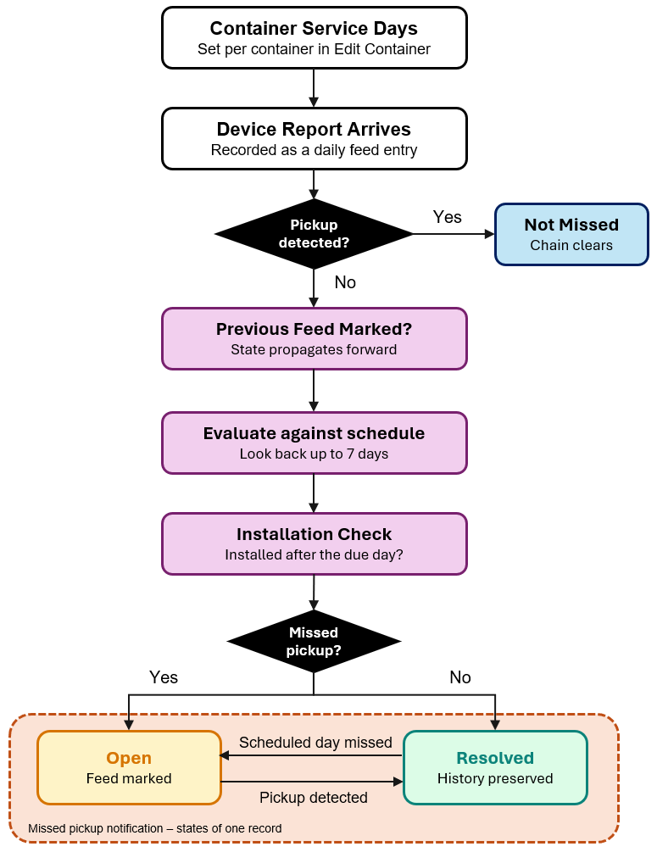
The previous figure traces the full sequence of a container missed pickup. The container's service days are configured in the Edit Container view. Each device report is recorded as a Daily Feed entry and then evaluated. If the report carries a pickup detected event, the chain clears and any open notification resolves. Otherwise the system checks whether the previous feed was already marked, and if not, looks backwards through the schedule to determine whether a pickup was due and not made.
Two characteristics distinguish this from a simple schedule check.
- The current day is never assessed. A pickup may still happen later in the day, so a scheduled day is only judged from the first report of the following day onward.
- The state propagates forward. Once a feed is marked missed pickup, every subsequent feed carries the same mark until a pickup is detected. This is why the badge appears on days that are not service days.

Inputs
Input | Source | Role
Service Days | Container configuration | Determines which days a pickup is due
Pickup Detected | Device provider, per report | Indicates the container was emptied
Previous feed state | The container’s preceding Daily Feed entry | Carries the chain forward
Installation date | The container’s most recent installation feed | Prevents flagging pickups that predate installation.

The evaluation draws on four inputs. Service Days are set individually, not as a frequency. The Service Schedule field displayed alongside them is derived from the selected days and is not itself an input to the evaluation.
Note: The evaluation uses the site's local date rather than a system-wide timezone, so a container is assessed against the calendar day at its own location.

User Roles
Missed pickup is entirely system-calculated and requires no user action. The only user-controlled input is the container's service days.
Description | Standard User | Administrator
View missed pickup notifications | 
View missed pickup events on the Daily Feed
Configure container service days | Permission-based

Configuring service days requires access to the Edit Container view. Where a user does not have edit permission for a container, the edit icon is not displayed, and the view cannot be reached.

missed pickup SYSTEM LOGIC
This section describes how a missed pickup is determined, when the evaluation runs, and how the resulting notification behaves. Diagrams in this section use two notations: a decision table for the rule set, and a BPMN process for the runtime evaluation.

Rule Set
The determination is a rule set evaluated in order, returning the first match.
# | Condition | Result | Reasoning
1 | The current feed carries a pickup detected event | Not missed | A pickup has occurred. Any open notification resolves and the chain clears.
2 | The previous feed was marked missed pickup | Missed | The state propagates forward on every subsequent feed until a pickup is detected.
3 | The container has no product or service schedule | Not missed | Cannot be determined. There is no expected pickup day to measure against.
4 | No scheduled day found in the preceding seven days | Not missed | Cannot be determined. A gap this long usually means the container is no longer in service.
5 | The device was installed on or after the most recent scheduled day | Not missed | No pickup could have occurred before the container existed on site.
6 | Otherwise | Missed | A scheduled day has passed with no pickup detected since.

- Rule 1 clears the chain. A detected pickup resolves any open notification regardless of what preceded it.
- Rule 2 propagates the state. Because it is evaluated before any schedule lookup, a chained missed pickup persists on every report, including on days that are not service days.
- Rule 3 requires a schedule. Without a configured product and service days there is no expected pickup day to measure against, so no determination can be made.
- Rule 4 defines the lookback. The system walks backwards one day at a time from yesterday, stopping at the first scheduled day it finds. If none is found within seven days, no determination is made. This limit exists because a container with no pickup for over a week is usually no longer in service and has been left active in the system, which is a condition for manual review rather than an automatic alert.
- Rule 5 protects newly installed containers. A container installed on Tuesday is not flagged for a Monday pickup it could not have received.
Info: Rules 3, 4 and 5 all return not missed, but they do not mean the same thing. Rule 5 asserts that no pickup was due. Rules 3 and 4 mean the answer cannot be determined from the available data. The system treats all three identically; when investigating, the distinction matters.

Feed Evaluation
The evaluation runs on every device report received on the asset feed endpoint.
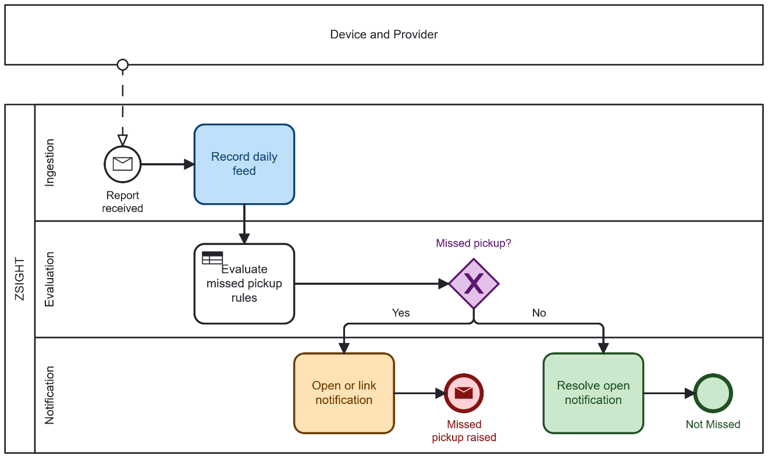

- Ingestion: Every report is recorded as a Daily Feed entry.

- Evaluation: The rule set defined in the previous section, is applied and returns a single result.

- Outcome: Where the result is missed, the feed is marked and a notification is opened, or the report is linked to an existing open notification. Where the result is not missed, any open notification for the container is resolved.
Because the current day is never assessed, a missed pickup is first detected on the earliest report of the following day. Report times vary, so the exact detection time varies with them.
Info: A container due for pickup on Monday that reports five times that day without a pickup detected event is not flagged on Monday. The determination is made on Tuesday’s first report.

Notification Lifecycle
Raising a missed pickup is an event within the evaluation process. What follows is the notification moving between two states, driven by subsequent reports rather than by user action.
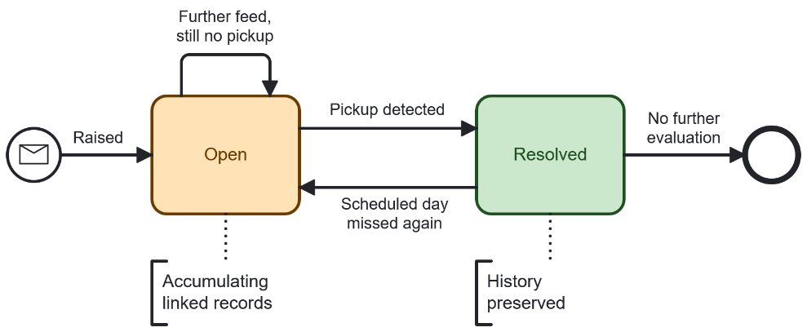
Status | Meaning
Open | A scheduled pickup has been missed and no pickup has been detected since.
Resolved | A pickup detected event was received. The record and its linked history are preserved; only the status changes.
Three behaviors follow from this model:
- Further reports do not create new notifications. While a notification is open, each subsequent feed links to the existing record and is itself marked with missed pickup.
- Resolution is automatic. A pickup detected event closes the notification. No user action is required.
- Resolved is not terminal. A later scheduled day passing without a pickup opens a new cycle.
The missed pickup event appears in three places: as a notification in the Notifications module, as a badge in the container’s Latest Events, and on each feed in the chain in the Daily Feed.
Note: A maximum of 20 linked feed records are displayed per notification. Remaining records are retained but not rendered.

Known Limits
Condition | Behavior
No pickup for more than seven days | No determination is made. The notification resolves and the case requires manual review.
Container has no service schedule configured | No determination is made
Container installed after the most recent scheduled day | Not flagged

missed pickup WORKING PROCEDURES
This section describes the one user operation that affects missed pickup evaluation.

Configure Container Service Days
Service days determine which days a pickup is due for a container. They are the only user-controlled input to the missed pickup evaluation.

Procedure
- Open the container from the Containers module to display the container details page.
- Select the edit icon, located to the left of the gallery and map mode icons.
- In the Edit Container view, locate the Days field in the Product section.
- Select the days on which the container is picked up. Multiple days may be selected.
- Select Save.
The Service Schedule field updates to reflect the number of days selected. It is derived and cannot be edited directly.
Warning: Changing service days changes which days are treated as scheduled pickups. A container with days removed will no longer be evaluated against those days.

APPROVAL SIGNATURES
Digital signature blocks below are formatted for DocuSign / Adobe Sign.
Name | Role | Digital Signature Block | Date (dd/mm/aa)
Approval’s name | Approval’s role |  | 18/08/2026

--- END OF THE DOCUMENT ---

